
Overview
What is the session about? What is the purpose? Who participated? Use these guide questions to create an informative overview of your one-pager document.
Approved | Name
 | Mention fellow Canva users in your Canva Doc. Just @ them directly on the document and tap the bell to send them a notification.
Summary
Key Information | Write the key details of the session  - Include relevant highlights  - Add additional information
Blockers | Write a blocker for the team, if any  - Provide context for your team
Next Steps | Write an action item that will move the team forward  - Assign a person person to the task
Support Needed | Write any support required  - Insert a date when it is needed
Relevant resources
Add link to resource here

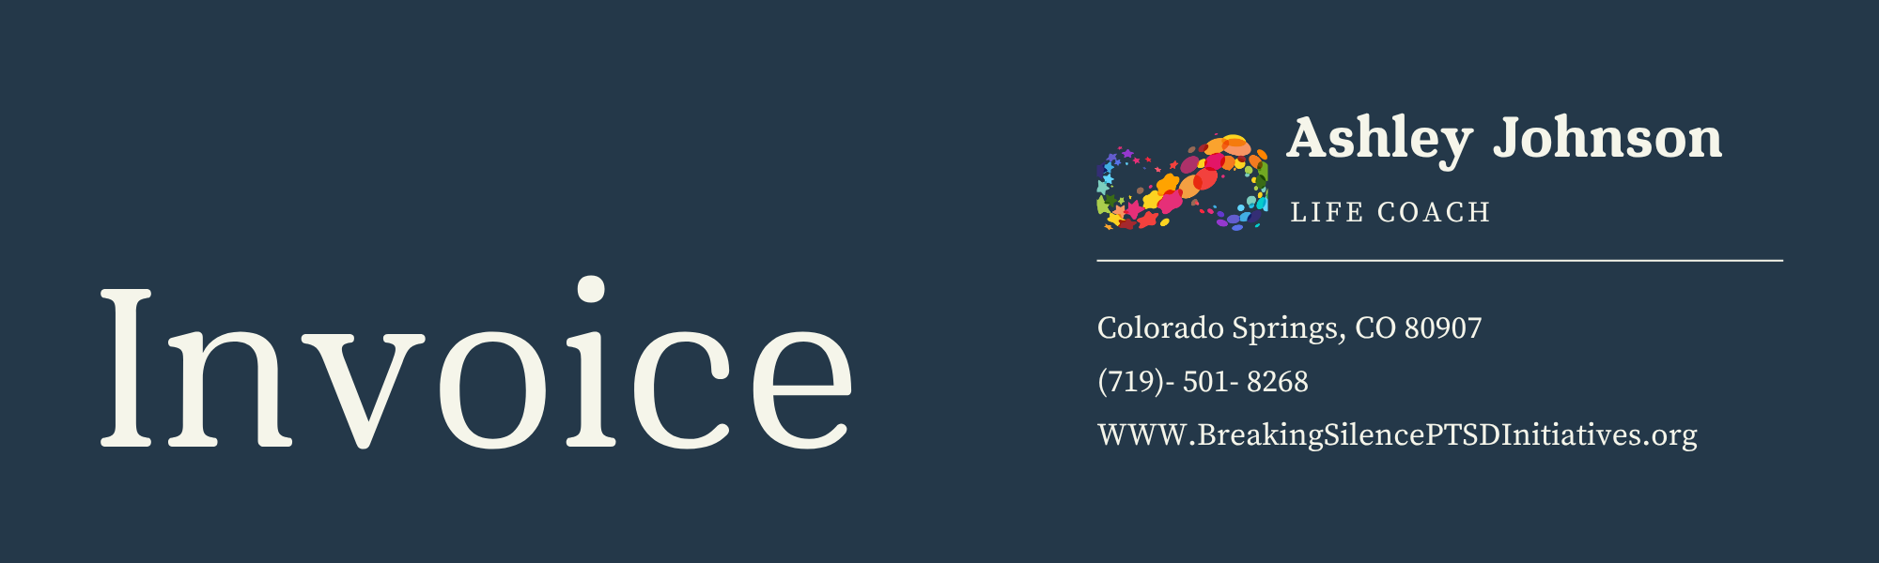
Invoice #: | Invoice Date:
Billed To: | Customer's Name:  Address:  Tax ID:
Description | Rate | Hours | Amount
Subtotal
Tax Rate (%)
Tax
Grand Total
Payment Information
Payment Due Date: | Account Name:
Bank Name: | Account Number:

Notes:
Please reach out to hello@reallygreatsite.com for other modes of payment.

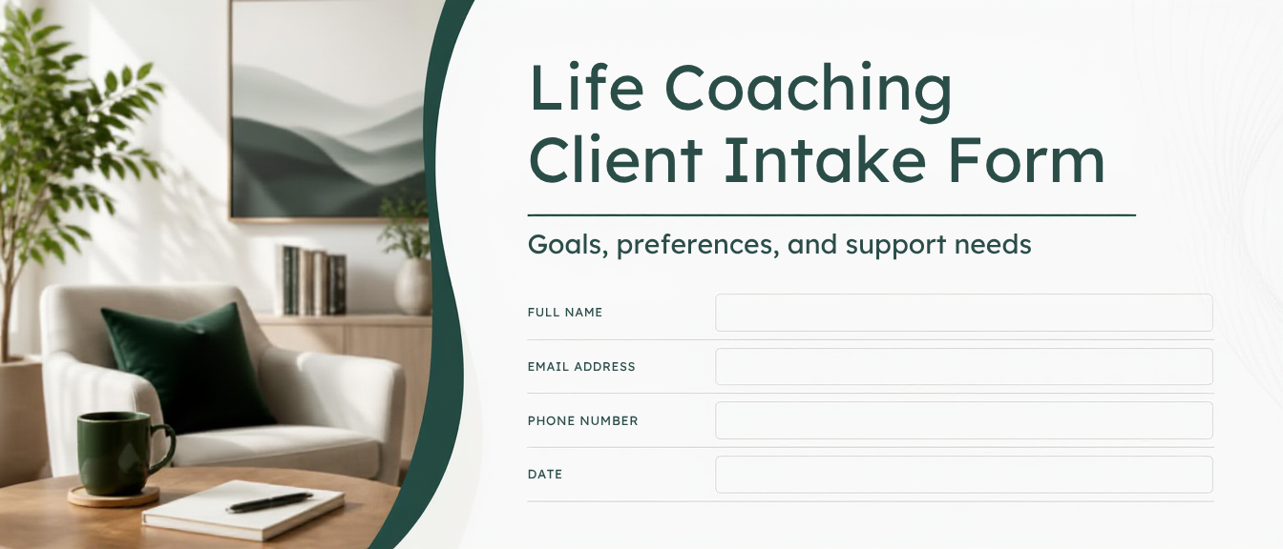
Life Coaching Client Intake Form
Goals, preferences, and support needs
Please complete this form as best you can. Your responses help shape a coaching experience that fits your goals, values, and needs. You can skip any question you’re not ready to answer.
Client Information
Full name: ________________________________
Preferred name (if different): ________________________________
Pronouns: ________________________________
Date of birth (optional): ____ / ____ / ______
Occupation / role: ________________________________
Time zone: ________________________________

Contact Details
Email  ______________________________ | Phone  ______________________________
Best way to contact you  Email  Text  Phone call  Other: ____________________ | Best times to reach you  ______________________________  ______________________________

Preferred communication between sessions:
None (session-only)
Email check-ins
Messaging / chat check-ins
Brief accountability reminders
Other: ________________________________

Emergency Contact
Name: ________________________________
Relationship: ________________________________
Phone: ________________________________
Notes (optional): ________________________________

Coaching Goals
In a sentence, what would you like coaching to help you with?
____________________________________________________________
____________________________________________________________

Top 3 goals for the next 3–6 months:
1) __________________________________________________________
2) __________________________________________________________
3) __________________________________________________________

How will you know coaching is working? (What would be different?)
____________________________________________________________
____________________________________________________________

Reasons for Seeking Coaching
What prompted you to start now?
____________________________________________________________
____________________________________________________________

What have you tried so far?
____________________________________________________________
____________________________________________________________

Current Challenges
What feels most challenging right now?
____________________________________________________________
____________________________________________________________

What tends to get in the way? (time, energy, mindset, support, habits, etc.)
____________________________________________________________
____________________________________________________________

Stress level lately:
Low
Moderate
High
Varies day to day

Strengths & Values
What are you proud of about yourself?
____________________________________________________________
____________________________________________________________

What strengths can we lean on during coaching?
____________________________________________________________
____________________________________________________________

Top values that matter to you right now:
Growth / learning
Health / wellbeing
Family / relationships
Freedom / flexibility
Purpose / meaning
Stability / security
Creativity
Contribution / service
Other: ________________________________

Key Life Areas
Which areas would you like to focus on? (check any)
Career / work
Relationships
Health / fitness
Mental health / stress management
Confidence / self-trust
Habits / routines
Time management / boundaries
Money / finances
Life transitions / decisions
Purpose / meaning
Other: ________________________________

Any context that would be helpful for me to know?
____________________________________________________________
____________________________________________________________

Support System
Who are the key people or resources supporting you right now?
____________________________________________________________
____________________________________________________________

What kind of support would be most helpful from coaching?
Clarity and goal-setting
Accountability and follow-through
Mindset support and reframing
Planning and prioritization
Confidence and motivation
Communication and boundaries
Other: ________________________________

Preferred Coaching Approach
What style do you prefer? (check any)
Gentle and encouraging
Direct and challenge-oriented
Structured with plans and homework
Flexible and conversation-led
A mix of structure and flexibility

What helps you stay engaged and consistent?
____________________________________________________________
____________________________________________________________

Anything you want to avoid in coaching?
____________________________________________________________
____________________________________________________________

Session Cadence
Ideal session frequency:
Weekly
Every other week
Monthly
Not sure yet

Preferred session length:
30 minutes
45 minutes
60 minutes
Other: ________________________________

Format preference:
Video call
Phone call
In-person (if available)

Action Priorities
If we could make progress on just one thing first, what should it be?
____________________________________________________________
____________________________________________________________

What would feel like a realistic “first step” this week?
____________________________________________________________
____________________________________________________________

How would you like to be supported with accountability?
Clear weekly actions
Tracking and check-ins
Celebrating wins and progress
Problem-solving obstacles together
Other: ________________________________

Additional Notes
Anything else you’d like me to know to support you well?
____________________________________________________________
____________________________________________________________
____________________________________________________________

Note: Coaching is a collaborative, forward-focused process. If you have concerns about your safety or wellbeing, please seek immediate support from local emergency services or a qualified medical/mental health professional.

Consent / Acknowledgment
I understand that coaching is not therapy, counseling, or medical advice.
I understand I am responsible for my own decisions, actions, and results.
I consent to engage in coaching and to discuss personal goals and challenges in a supportive, confidential setting (within applicable legal/ethical limits).

Client signature: ________________________________
Date: ____ / ____ / ______

